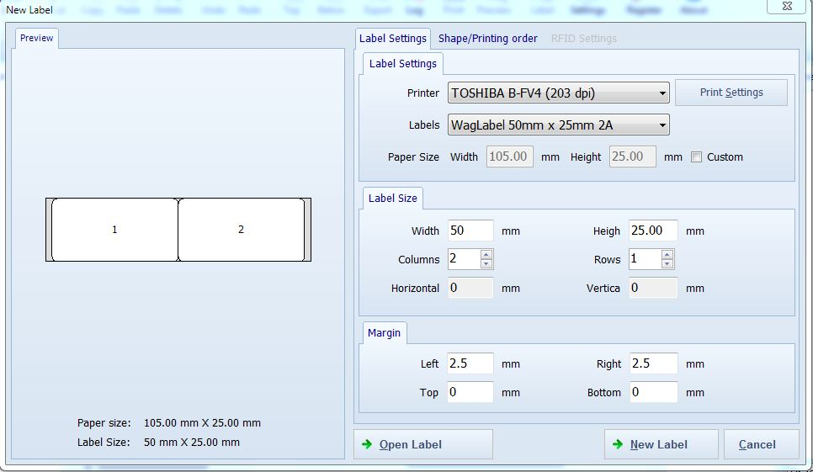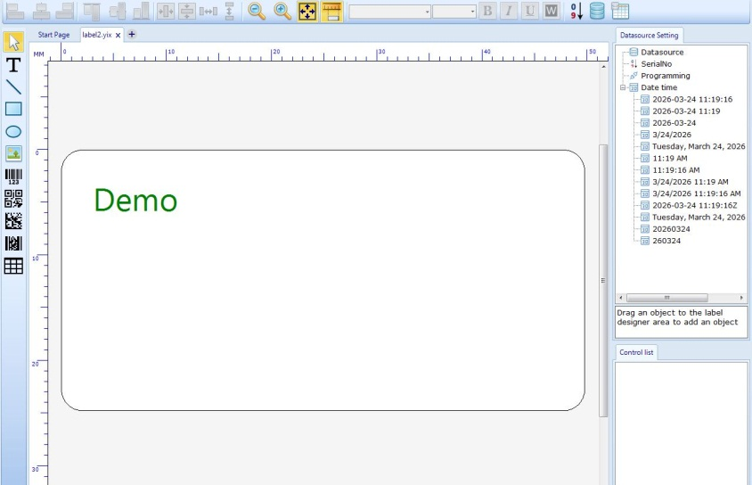
1) Open the application.
- Choose either Create New Label or open an Existing Label.
- Click on New Label → the Label Settings window will appear.
- Enter the required details:
- Width and Height
- When Number of Rows and Columns added in printing everything should be visible
- Horizontal and Vertical spacing and spacing in between two labels should be added
- Set the margins and space between should be possible:
- Left
- Right
- Top
- Bottom
- Click OK / Apply → a blank label will be displayed.
- From the left-side toolbar, select the Text tool (Text Symbol).
- Click on the blank label and edit/add text as needed
- Label Scale Layout should be in mm and Color should be black
- Label should be curved rectangular
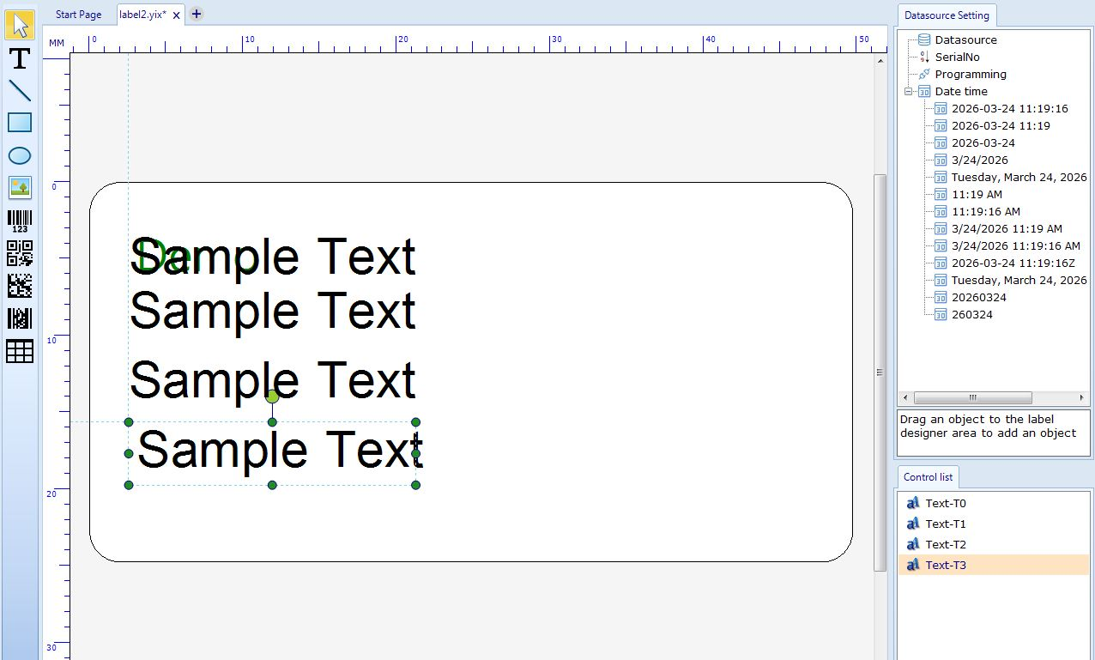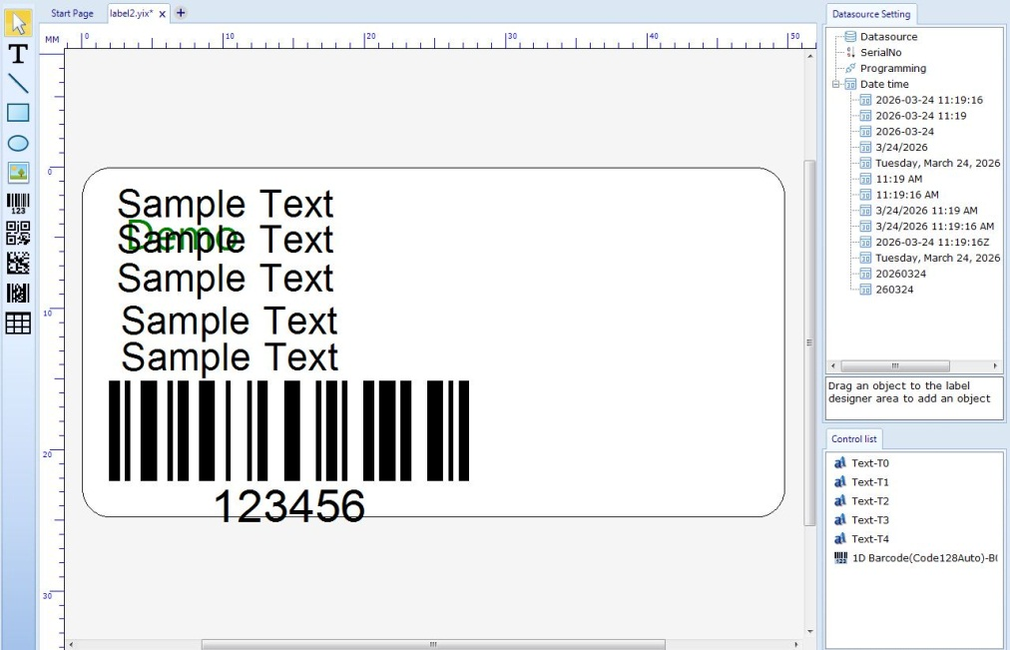
  - Copy and paste the sample text using Ctrl + C and Ctrl + V
  - Use the left-side Barcode Tool to insert a barcode
  - When editing the text below barcode it should not be merged with the barcode and Edit only the text below the barcode even when resized
  - Change the font style and font size as required

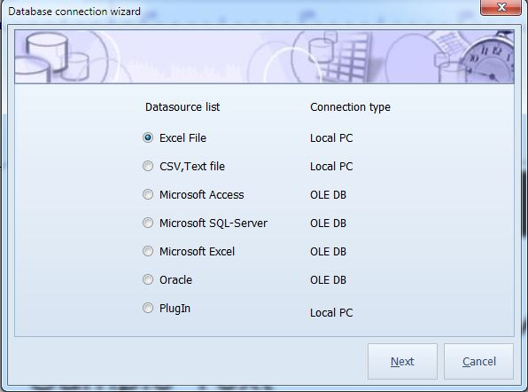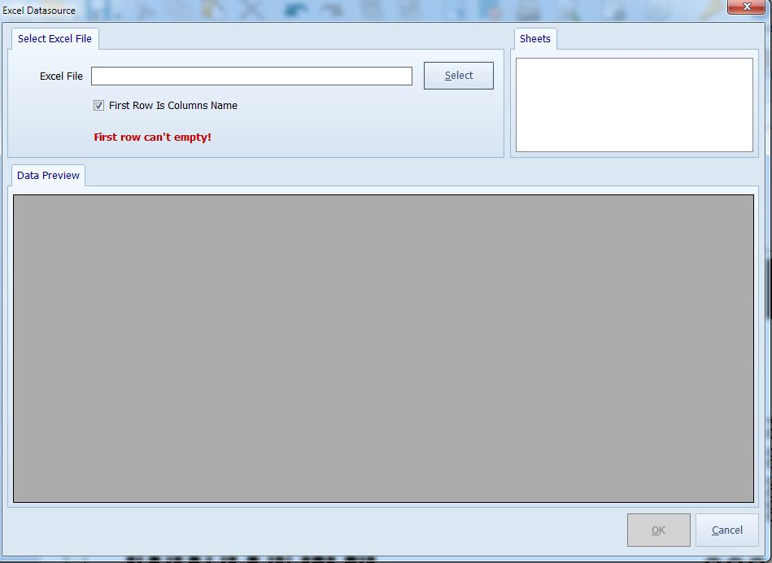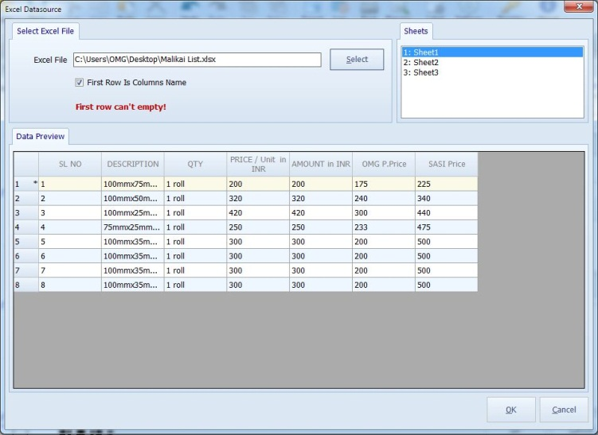

- Click the Data Source icon (top-right corner)
- Open the Data Source List
- Select Connection Type → Excel
- Click Next

- Browse and select the required Excel file
- Click Open
- Data source preview will be displayed

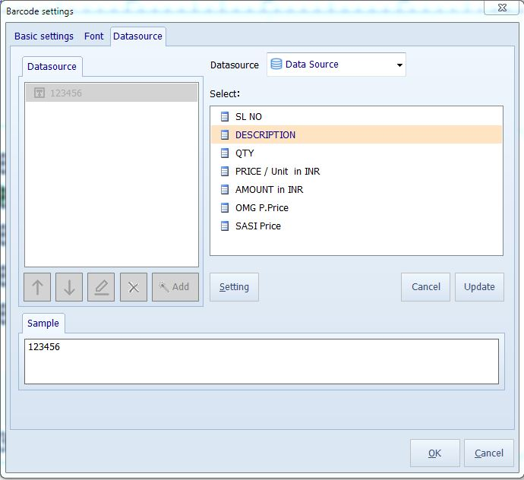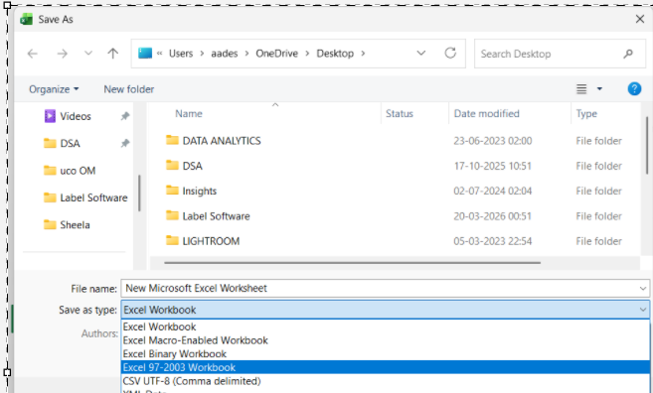

- Excel Files Format should be in the above 3 Formats
- Excel Workbook, Excel 97-2003 Workbok and Orginal Excel should be supported

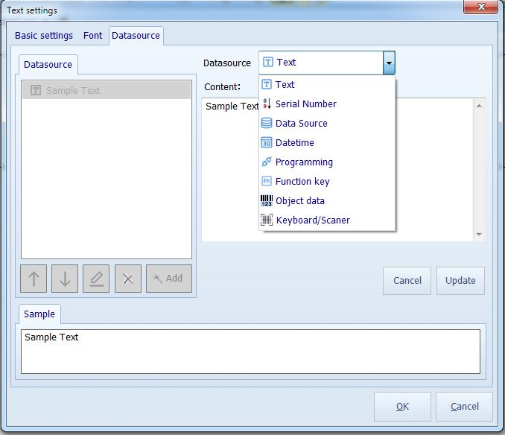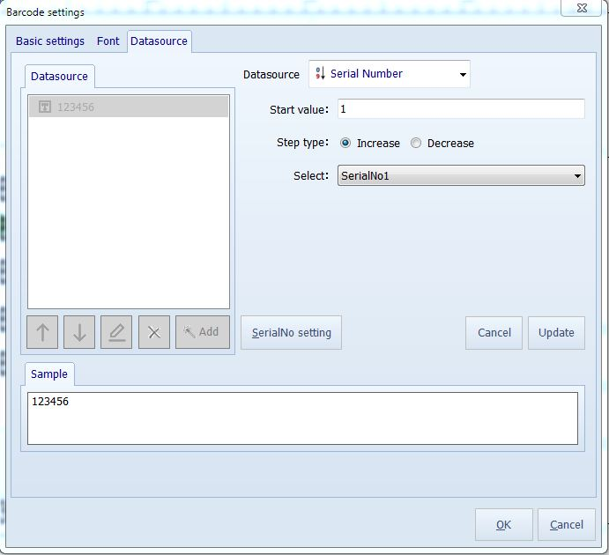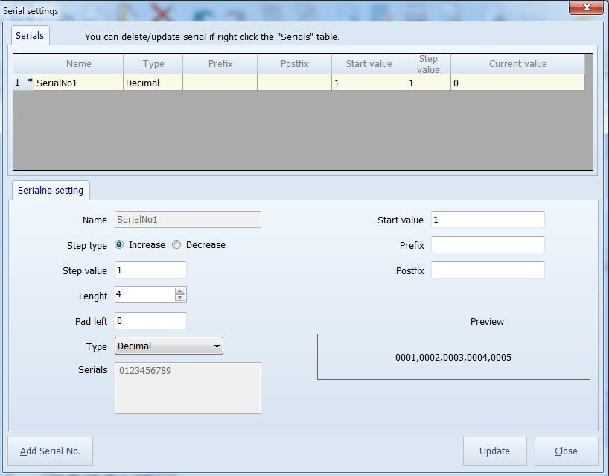

- Serial number should be updated and when starting from 00001 it should display as 00001 not as just 1
- Select the required field names for each text element
- Double-click the sample text
- Adjust the Increase/Decrease settings
- Set the Step Value:
- Step Value = 1 → 001, 002, 003
- Step Value = 2 → 001, 003, 005
- This controls how serial numbers increment during printing
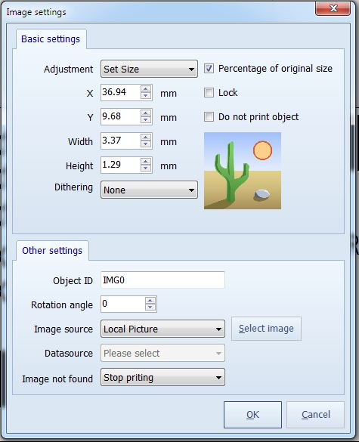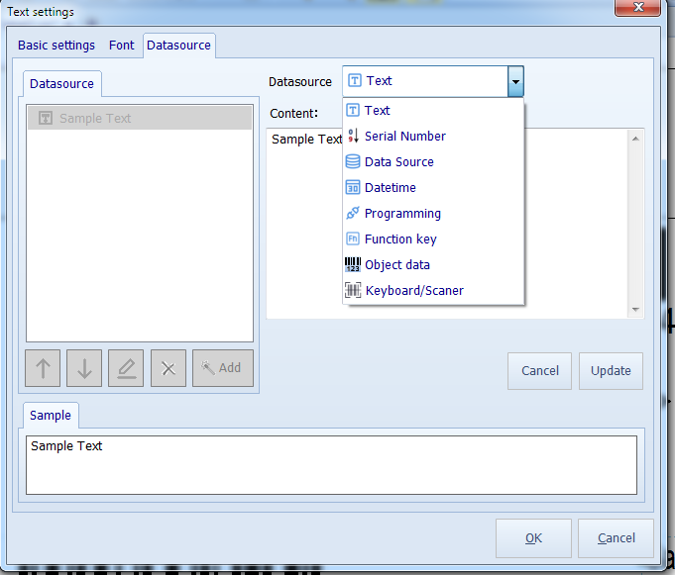

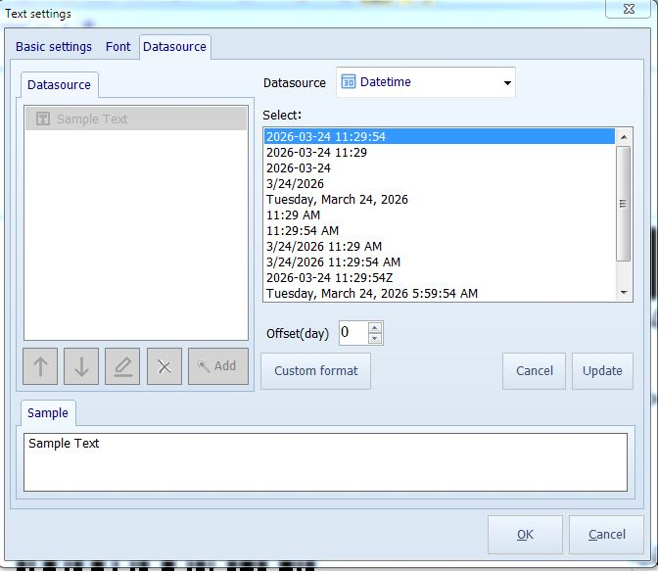
  - Click the Image icon from the left toolbar
  - Add and edit the required image/logo
  - Double-click the sample text
  - Select the Date & Time field
  - Choose the required date format

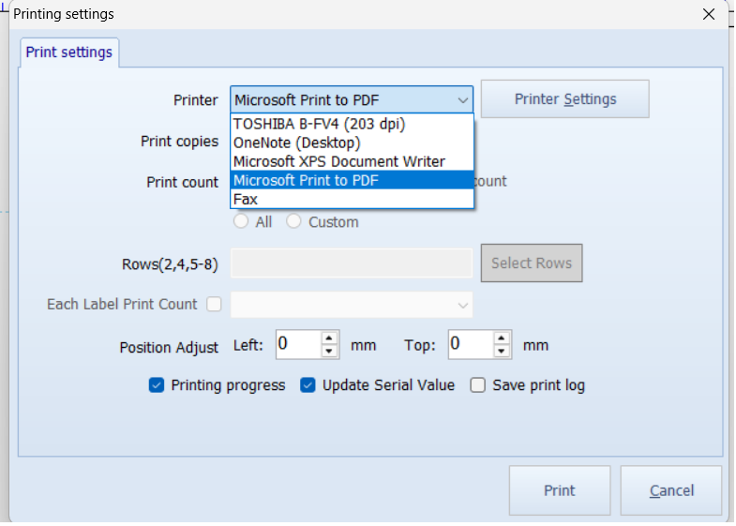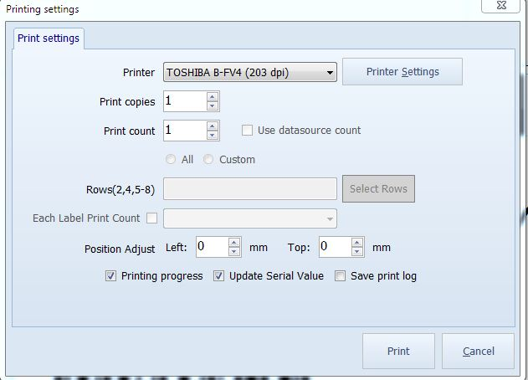

- All the printer must be displayed under printer settings
- Press Ctrl + P to open print settings
- Click printer show the control panel all printer names
- Select the printer name
- Click Print

- To adjust speed and darkness:
- Click Printer Settings
- Open the Control Panel / Driver Settings
- Modify settings as required

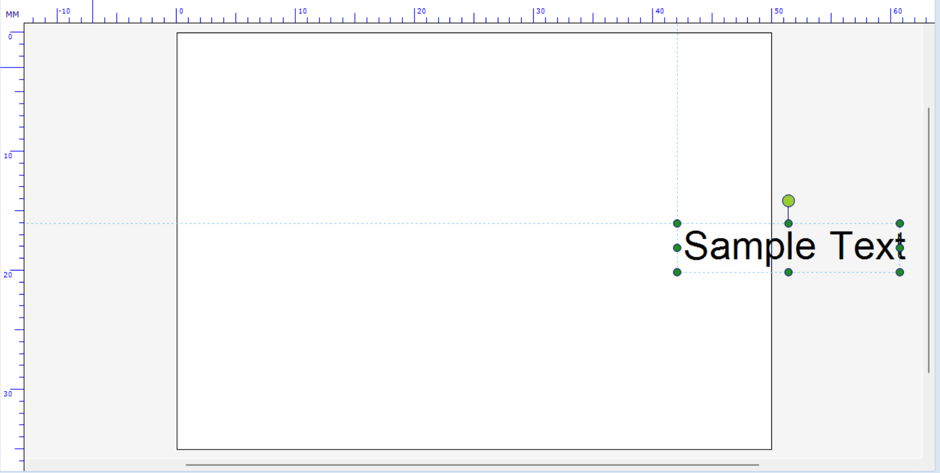

- When text or any element or any item is moved outside the label it should be visible even outside the label it should not disappear
- Under elements Circle also must be added

